DAGENHAM & DISTRICT
CAGE BIRD SOCIETY NEWSLETTER

MAY 2023

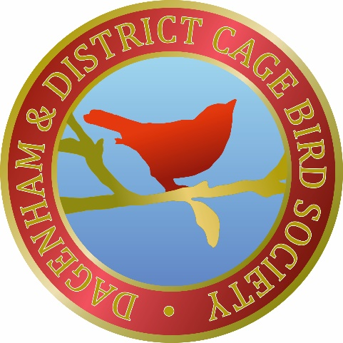

NEXT MEETING
Saturday, 20th May
10am to 12pm

SONG BIRD COMPETITION
To be judged by the Members

(Please see inside for more information)

SALES TABLE AT EVERY MEETING

Committee Members 2023

Dagenham and District
Cage Bird Society
Meetings held at
Wantz Hall
Rainham Road North
Dagenham, Essex
RM10 7DX

PRESIDENT
Peter Decort
5 Campbell Close
Collier Row
Romford, Essex
RM1 4SA
0772 666 4671

CHAIRMAN
Barry Johnson
01708 348330

TREASURER
Peter Decort
0772 666 4671

SECRETARY
Richard Wilson
Mitchells Farm
London Road
Stapleford Tawney
RM4 1SP
07852 959447

SHOW SECRETARY
Geoff Louth
07900 380 765

President PETER DECORT
Vice President Vacancy
Chairman BARRY JOHNSON
Vice Chairman Vacancy
Secretary RICHARD WILSON
Asst. Secretary Vacancy
Treasurer PETER DECORT
Publicity & Raffle BARRY & VAL
Newsletter BARRY & VAL
Show Manager STEVE WALLIS
Asst. Show Managers LES RIX and DAVE MASON
Show Secretary GEOFF LOUTH
Trophy Secretary LES RIX
Canteen FRAN, VAL & BARRY

And DICK LATHLEIFF, MICK PEGRAM & TED PAPANDREAS

Meetings are held on the third Saturday of the month at 10am to 12pm at Wantz Hall – Rainham Road North – Dagenham – Essex RM10 7DX

Committee Meetings

The Show Committee will arrange the Shows. General Committee Meetings will be arranged as and when needed. All Meetings and decisions will be reported by the Secretary in the Newsletters

SUBSCRIPTION RATES FOR THE CALENDAR YEAR 2023
Single £15.00
Partnerships: £20.00
Juniors (to 16): FREE

If anyone would like to contribute an article to the Newsletter about their birds or their showing – or anything else – please speak to Barry or Val at any of the meetings or e-mail them at the addresses shown below.
Barry (lukeira@btinternet.com) Val (valkenh@btinternet.com)

Forthcoming Meeting Dates
2023
Sat 20th May Song Bird Competition
Sat 17th June Malcolm Thornton – Foreign Finches
Sat 15th July Imperial Bird of Prey Academy
Sat 19th Aug Jim Galbally – Weeds, Seeds & Live Food
Sat 16th Sep Lawson & Wells Partnership – Our Birds
Sat 21st Oct Club Show League – Second Round – Hen Bird Show
Sat 18th Nov Young Stock Show (10am to 2pm)
Fri 8th Dec Staging for Open Show followed by Christmas Raffle Draw and Buffet (8pm to 10pm)
Sat 9th Dec Open / Annual Show (all day)
2024
Sat 20th Jan AGM

The President’s Comments

On behalf of Dagenham CBS I would like to thank all those that helped arrange the Sales Day on the 15th April. All went like clockwork, from getting the hall ready to helping see the birds and equipment to their relevant tables. It was lovely to see so many different types of birds for sale, also many types of cages and equipment and lots of different seeds, etc.

I hope everybody had as good a day as I had and people with things for sale did well. The Canteen was very busy all morning selling tea, coffee and snacks.

I personally hope this was not just a one off, and that there will be many more of these events. It would be nice to have two a year - i.e. one before the breeding season commences so that people could perhaps pick up anything they need to start the season, then one after the moult so people can sell off their excess birds.

Another thought would be could we hire the hall for a bit longer to give sellers a little bit more time? Also, perhaps we could look into hiring the hall for a different Saturday in the month to run alongside our usual Saturday?

If anyone would like to see more of these events held at our Club please
approach someone on the Committee and share your views so perhaps it can be brought up at one of our monthly meetings.

Birds – I was talking to some Members recently about how their breeding season has started. Some have had a not very good start with their Hens going down to nest, laying eggs only to find them clear. While others are having some clear eggs and some full ones. One even has a nest of four, all doing well. It is early in the season so hopefully it will pick up in the following rounds so good luck to all.

Over the many years that I have had my birds, at first I had some with my Dad, then as I got older I had my own part of the Shed. This is how I think most juveniles start, but we all have to start somewhere. My Dad had Borders, Norwich and British, but I loved Norwich and British.

When I was at home my Dad and I built a semi internal flight on the back of the main Shed. Onto this we built an open flight, approx. 18’ x 18’ x 7’ high. This was planted with small trees and some conifers and we used to tie pieces of fir branches all round the corners.

I had pairs of most types of British in this structure and I bred a few British and some Hybrids. I never used to show British. These were just for me to sit and watch.

With regards to the Club, I have been coming ever since I can remember. At first Dad did not have a car. He had his old trusty bike, so I used to sit on the crossbar, the handle bars and the seat he made. This he used for work and for going to the Clubs. He belonged to many including Romford, Brentwood, Rainham, Purfleet and, of course, Dagenham. These were lovely times as all my family were involved in the Club scene, except my older brother. He was a music man and he could play many instruments. He and his mates formed a group. Alas how things change.

I still have some birds, but not like I used to have. Over the years having birds has become a bit of a chore, so I now have only a small flight with some Gouldians and Zebras. I still love to see all the different breeds and still think of getting some more, but alas, I think this is only a dream as they would, at my age, become too much work.

But it is lovely to dream of days gone by. I do not know how much longer I will keep birds for but one thing I do know, is that I will hopefully be coming to this Club till I die. It is my only true Club. Always has been and always will be. I have met so many good friends. Friends I would never have met but for the Club.
Pete
The Club Secretary’s Comments

April’s meeting was our first sales day which went very well. The sellers were in at 9.30 to set up and the public and members were let in at 10am. It was a great sight to see so many people queuing up to get in. There were plenty of good birds available for sale and some great equipment on offer too and I think you could say the day was a fantastic success with many people asking when the next sale was.

A big thank you goes to Jamie Taylor & Shane Evans for organising the sale of the tables and managing the sellers, members, and general public in the hall on the day. Thank you also to the kitchen team and to Mick Pegram and the usual members who always help set up and most importantly pack away and clean the hall. May I remind everyone that these people are also paid-up members who give their time to the club. So, if you can spare 15 minutes to help, please do so. Thank you.
Richard

May 2023 Meeting

Our next Meeting is on the 20th May and will be the Song Bird Competition with the winner being chosen by the Members.

This will be the fourth time Dagenham CBS has held the Song Bird Competition and the rules are simple. So whether you like the field song of a Goldfinch, the vocal power of the Canary, Mule or Green Singing Finch, or maybe the chatter of the Zebra Finch or Budgie, there will be something for you. Everyone has a favourite.

Members can enter as many birds as they like (50p per bird). Birds can be in any suitable cage (it doesn’t need to be a show cage). Each bird will be given a number and placed on the staging.

We can then all sit down and have a cup of tea and something to eat and talk about how the breeding season is going so far while all the birds are singing away.

At the end of the Meeting all Members present will be able to vote on which bird’s song they liked the best and the winning bird will receive a rosette and a £20 cash prize.

Show Prize Money Fund

There were two donations in April:-
Les Rix donated £10.00
Peter Decort from sale of birds – £40.00

January Steve Smith donated £50.00
Allan Morton donated £10.00
February Milton Savva donated £20.00
John Young donated £5.00
Jim Galbally donated £20.00
Richard Wilson donated £40.00
Allan Morton donated £10.00
February’s Cock Bird Show Entries – £30.00
March Valerie Holmes donated £20.00
Richard Wilson donated £25.00
Sales table – £5.00
Unclaimed Spot the Member prize – £10.00

TOTAL to date = £295.00

Thank you to all who have donated to the Club to help generate funds to go towards the prize money for the Club Shows. The amount raised last year was £854.00.

Useful Numbers and Contacts
Rings
IOA (International Ornithological Association) Website – www.ioa-com-uk.org For all rings call Richard Lumley on 01653 697565

Email - ruby@lordlumley.plus.com
Richard is very helpful and provides a great service. The IOA are also sponsors of Dagenham CBS.

For closed or split rings email or call Hans Herr in Germany. Contact Melanie Siegel she speaks very good English, is very helpful and quick, I ordered & paid for rings on a Wednesday and I received them on the Monday. The quality of the rings is excellent.
Website – www.vogelringe.de Phone: 0049-721-686023
Fax: 0049-721-683029 - E-Mail: ma.herr@vogelringe.de

This Year’s Club Sponsor
Direct Bird Products – Shane Evans

Don’t forget you can ring Shane and give him your order
which he will bring to the next meeting or he can post it to you.
Please see the details in his advert at the end of the Newsletter.

Members’ Recommendations

Suppliers of Colour Food by The Standard Laboratory
Carrophyll Red/Orange/Yellow
Contact George Weeks Phone: 01959 576 998 or
E-Mail: george@standardlabs.co.uk

Wiltons Pets Phone: 01268 726 216

Gladwells Pet & Country Store
(Essex) Phone: 01268 642 601

DG Pest Control - David Galea Phone 01708 472172 or
(Club Member) 07882 951 578 (Mobile)
E-Mail davidgalea@live.co.uk www.dgpestcontrol.co.uk.

Latchford Farm Aquatics, Upminster
Bird, Fish and pet supplies Phone: 01708 641363

Items for Sale

If you have any birds or equipment for sale please bring them to the Club or let Barry or Val know and they will add it to the next Newsletter.

Items wanted

If there are any birds or equipment you want please let Barry or Val know what you are looking for so that it can be added to the next Newsletter.

Please note, adverts in the “For Sale” and “Items Wanted” sections will only be included in two Newsletters. If you want your advert in after the two months please let Barry or Val know. Thank you.

Treasurer's Monthly Report & Attendance for April 2023

Raffle made £135.00 Current Members present 48
Tea Bar made £118.00 Guests 64 app.
Donations £0 New / Returning Members 4

Sales Day Income
10 members’ tables £ 50.00
17 non members’ tables £170.00
47 people entry £141.00
1 x new partnership £ 20.00
2 x new single members £ 30.00
£411.00

The £50.00 Membership Subscriptions will go to Club Funds and the balance of £361.00 will go to the prize fund and will be shown in next month’s list.

Raffle
There was no £50.00 prize this month
Our thanks to Vista Workspace Solutions
for their sponsorship and the raffle prizes

There was no seed raffle this month

New and Returning Members

There were two new Members and a Partnership at the April Meeting
Welcome to Glenn Lewingdon who keeps Canaries & British and
Kirk Norcross who keeps Canaries
Our new Partnership is Grant and Dean Watkins who keep British
We also had a returning Member so welcome back to
Kirk Johnson who keeps British

The Club’s Website, etc

The Club’s website is www.dagenhamcbs.com. You can find out all about our Club right back to 1935 – Newsletters, Shows, history and much more.
The Club can also be contacted by e-mail – info@dagenhamcbs.com – or via our Facebook page.

Dagenham CBS Facebook and Group Page: We now have 438 Members on the Group Page. Please give it a look and join in the banter and the up to date news from the members.

Members’ Info.

Mick Pegram is still dealing with most of the posts on our Facebook page. Please don’t forget to let Richard have your contact details if you are happy for them to be put onto the website page. This will allow members, especially those who are not on Facebook, to stay in touch and give advice and help to other members who keep the same species or share the same problems.

Mick Pegram’s “Spot the Member” give-away

Mick is continuing with his monthly “Spot The Member” and will be donating £10.00 to the Member who is circled in the following photo. The winner will be picked at random by a non-member who does not know anyone at the Club. The prize must be claimed at the next Meeting otherwise the £10.00 will be donated to the Club.

Last month’s prize was won by Les Rix and he kindly donated it to the Club’s Prize Money Fund.

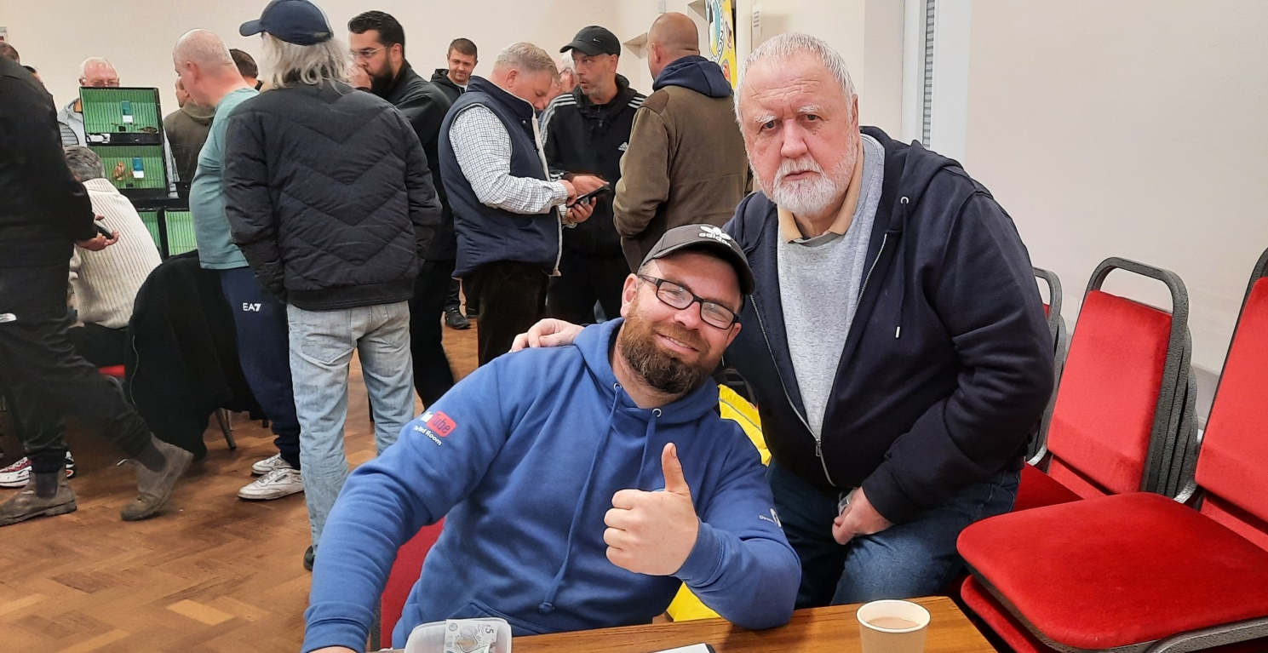

Membership Subscriptions

The Club’s year runs from January to December
If you know anyone who is unable to get to the Meetings they can send their 2023 subs to Pete (details at the front of the Newsletter)

Cheques should be made payable to
Dagenham and District Cage Bird Society

Single – £15.00.….Partnerships – £20.00….. Juniors (to 16) – Free

Members’ Christmas Raffle

Richard is continuing the Members’ Christmas Raffle again this year. Every Member who is signed in at the Meetings will receive one entry for each Meeting attended. The draw will take place at the December Meeting and the winner will receive a cash prize of £100.00 donated by Vista Workspace Solutions. To win the prize you must be at the Meeting on Friday, the 8th December otherwise another ticket will be picked until a winner is declared.

The usual monthly raffle will still take place on the Friday night, with its £50.00 cash prize plus other prizes as normal.

Bird Keepers Association

This year’s remaining sale dates are
17th September and 19th November
Please see the poster/flyer with this newsletter

Some Photos from last month’s Meeting

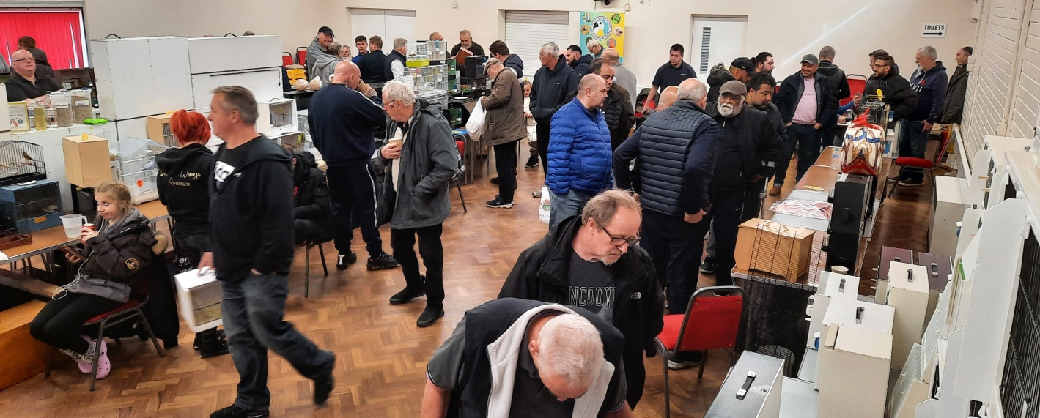
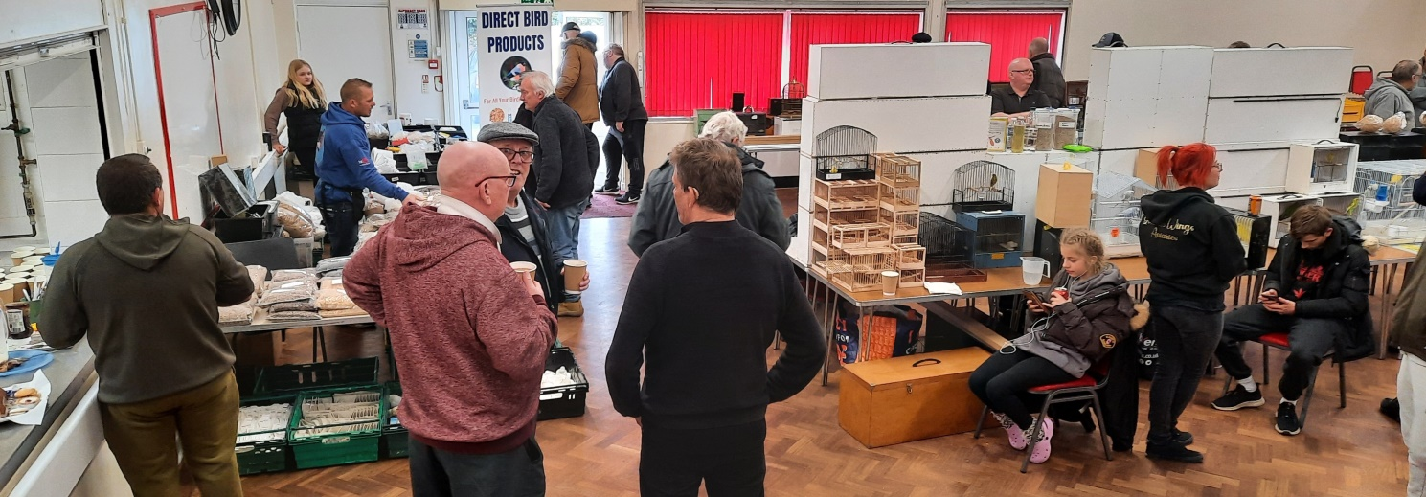

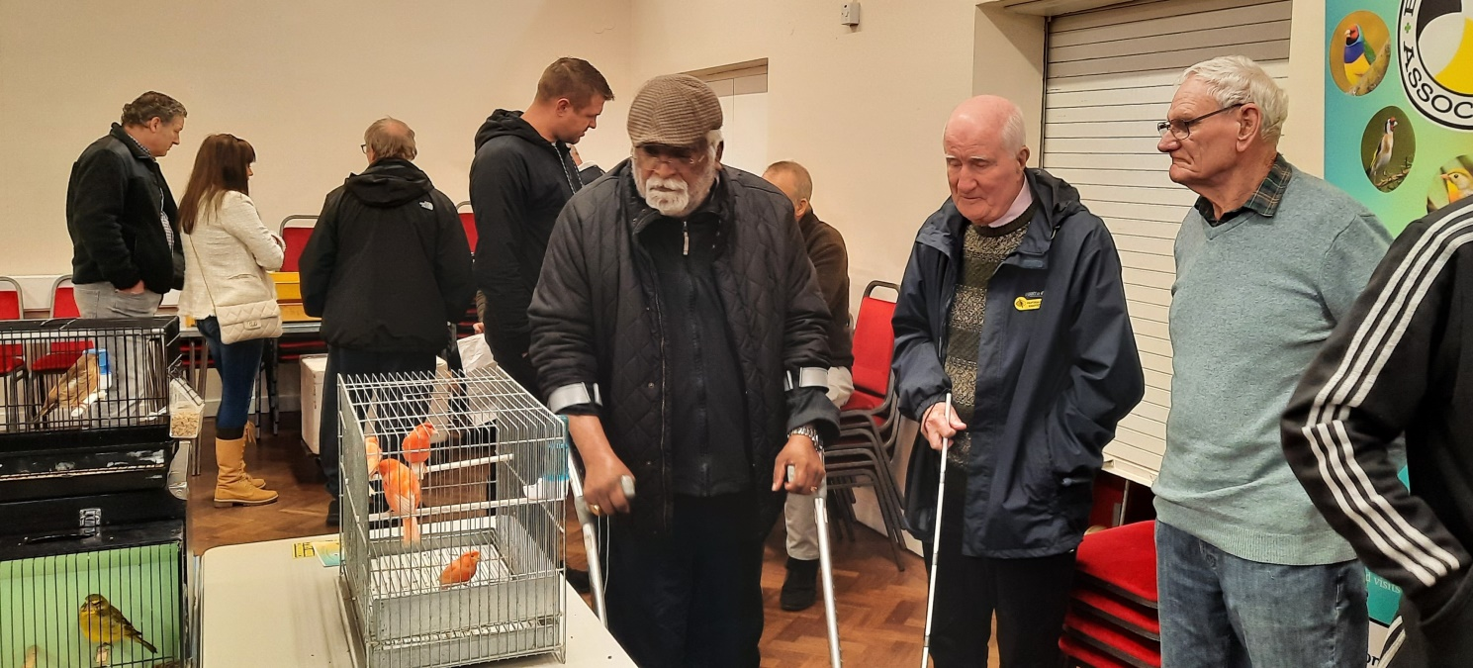

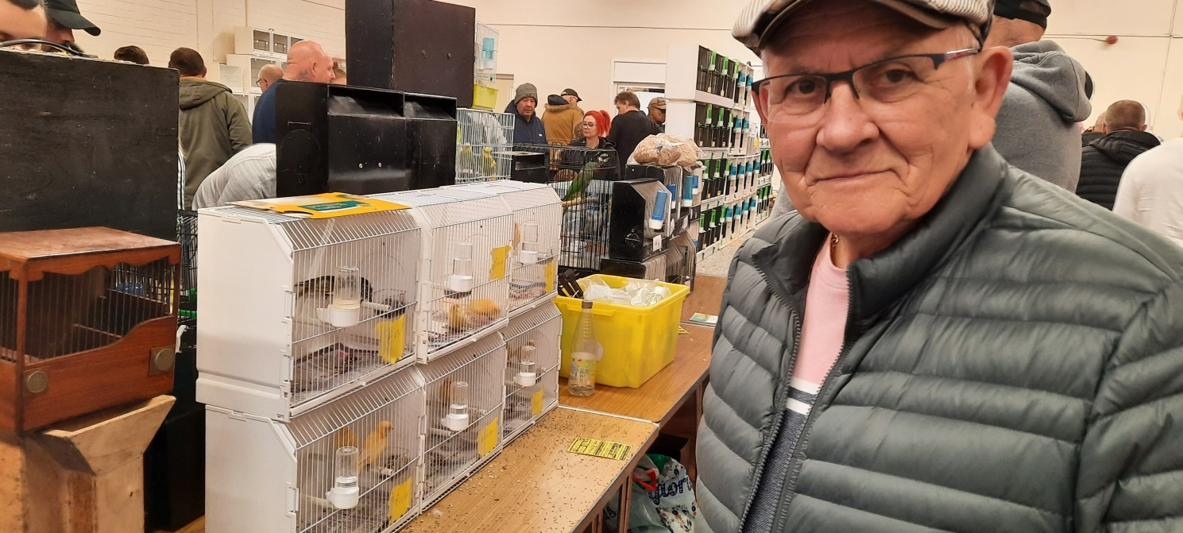

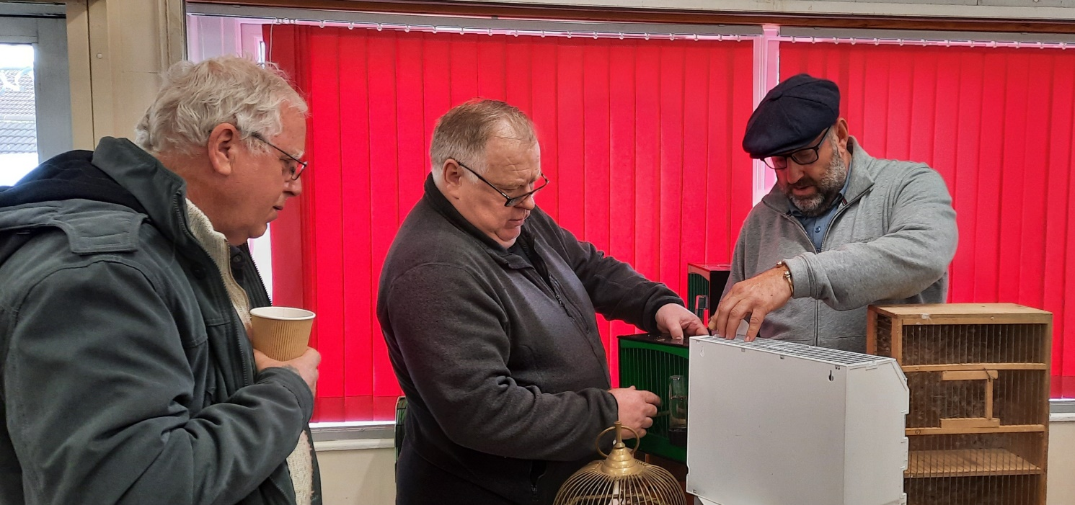

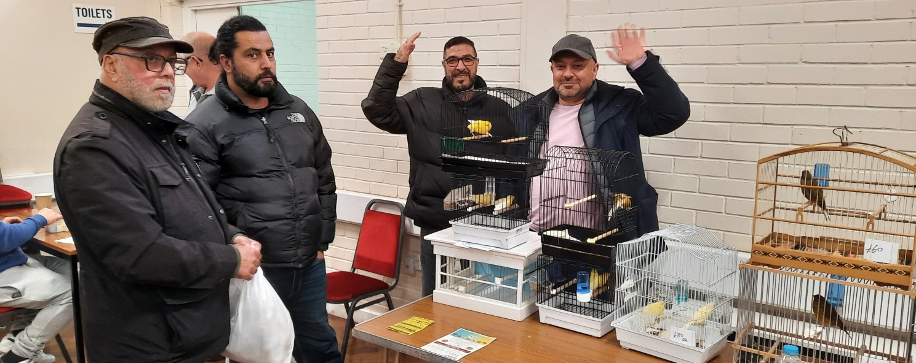

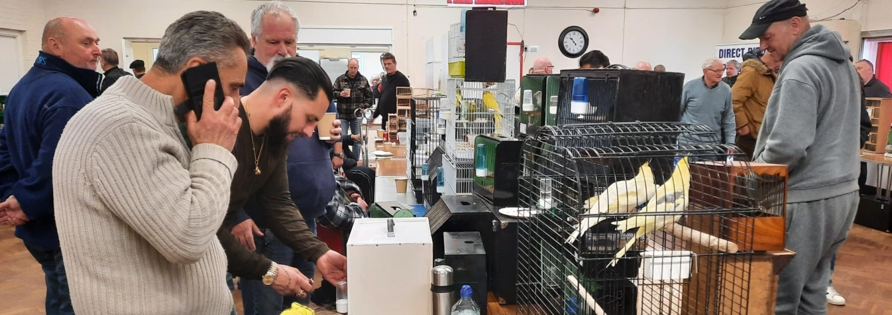

Club Sponsor

Direct Bird Products is this year’s Club Sponsor and are suppliers of seed and equipment. They are happy to post Members’ orders to them or deliver to the hall on meeting days. They also plan to have a sales table at every meeting.

Members can contact them by calling Shane Evans on 07376 669 333 or message on Facebook Direct Bird Products.

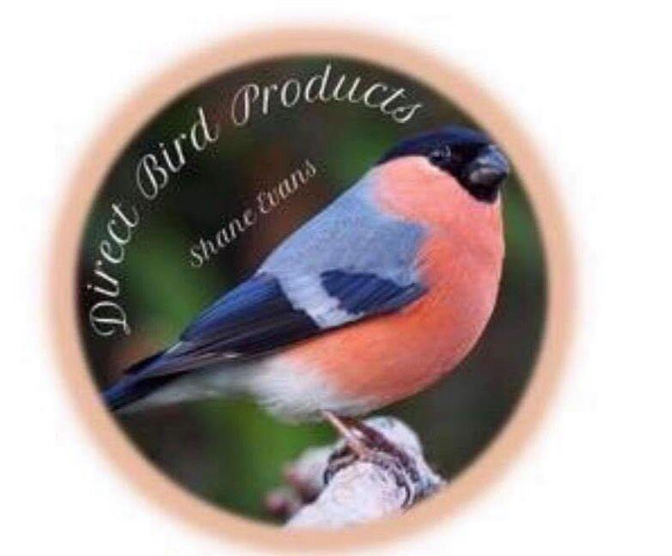

Find us on
Instagram: Direct Bird Products
Facebook: Direct Bird Products
YouTube: The Bird Room
Website: directbirdproducts.com
Now taking all major Credit Cards & PayPal
